Unit III: Exploratory Data Analysis (EDA) (6 Hours)
EDA is a critical step in Data Science where we explore, summarize, and understand data before applying machine learning models. It helps uncover patterns, spot issues, and generate hypotheses.

EDA is a critical, initial data science approach used to analyze, visualize, and summarize datasets to understand their structure, spot anomalies, and detect patterns. It employs visualization (plots) and statistics to test assumptions before formal modeling, often reducing errors and optimizing feature selection.

Importance
- Provides a clear understanding of the dataset, including the number of features, data types and data distribution.
- Reveals patterns and relationships between different variables in the data.
- Identifies errors and outliers that may affect analysis.
- Highlights the most important features useful for building models.
- Supports selecting suitable modelling techniques for better results.

Types of Exploratory Data Analysis
1. Univariate Analysis
Univariate analysis studies one variable at a time to understand its characteristics and distribution.
- Histograms: Show how data values are distributed.
- Box plots: Help detect outliers and show data spread.
- Bar charts: Used for categorical variables.

2. Bivariate Analysis
Bivariate analysis examines the relationship between two variables to understand how they interact or influence each other. Common techniques include:
- Scatter plots: Show the relationship between two numerical variables.
- Correlation coefficient: Measures the strength of the relationship between variables.
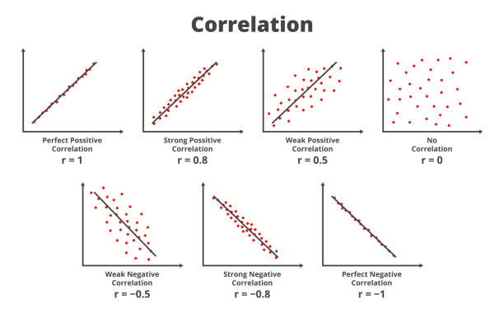
- Cross-tabulation: Displays the relationship between two categorical variables.
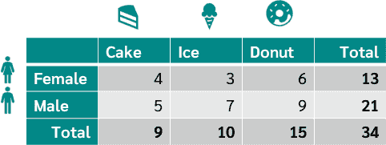

- Line graphs: Compare two variables over time to identify trends.
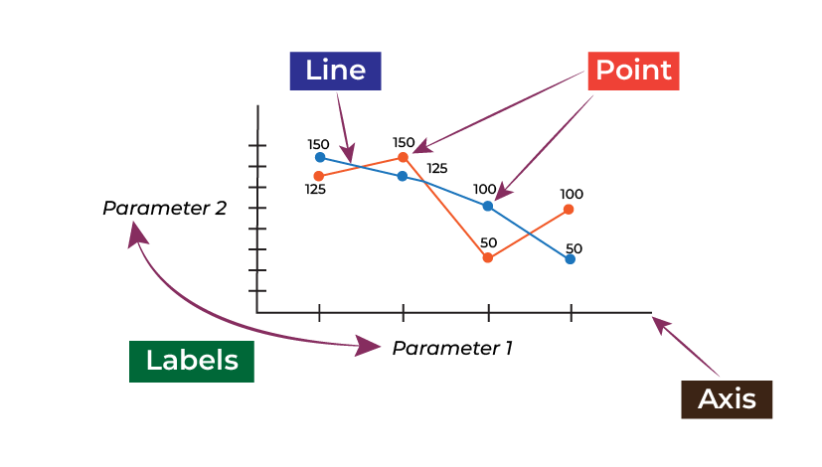
- Covariance: Shows how two variables change together.

3. Multivariate Analysis
Multivariate analysis studies three or more variables together to understand complex relationships within the dataset. Common techniques include:
- Pair plots: Show relationships between multiple variables at once.
- Spatial analysis: Analyzes geographical patterns using maps and location-based data.
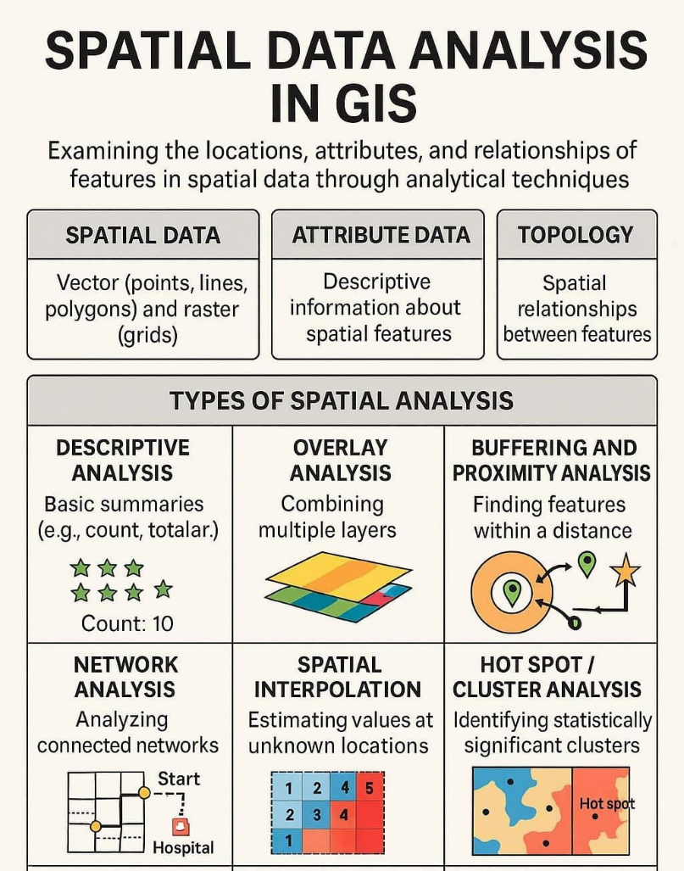

Steps for Performing Exploratory Data Analysis
EDA involves a set of steps that help us understand the data, find patterns, detect issues and prepare the data for further analysis or modelling. It can be performed using different tools like:
- Python: Pandas for data manipulation, Matplotlib and Seaborn for visualizations and Plotly for interactive charts.
- R: ggplot2 for visualizations, dplyr for data manipulation and tidyr for organizing data.

Common steps included in EDA
Step 1: Understanding the Problem and the Data
The first step in any data analysis project is to fully understand the problem we're solving and the data we have. This includes asking questions like:
- What is the goal or problem we are trying to solve?
- What variables are present in the dataset and what do they represent?
- What types of data are available (numerical, categorical, text etc.)?
- Are there any data quality issues or limitations?

Step 2: Importing and Inspecting the Data
The next step is to load the dataset into tools like Python or R and inspect it. These checks give a basic understanding of the dataset.
- Load the dataset properly.
- Check the number of rows and columns.
- Identify missing values.
- Verify the data type of each variable.
- Look for errors, invalid values or unusual data points.

Step 3: Handling Missing Data
Missing data is common in many datasets and can affect the quality of analysis. During EDA, it is important to identify and handle missing values properly to avoid incorrect results.
- Understand why data is missing, as this helps in selecting the right approach.
- Decide whether to remove or fill missing values, since removal can cause bias while imputation preserves data.
- Use suitable imputation methods such as mean, median, regression or machine learning techniques like KNN or decision trees.
- Consider the impact of missing data, as it can still introduce uncertainty even after imputation.

Step 4: Exploring Data Characteristics
After handling missing data, the next step is to examine the main characteristics of the dataset. This helps us understand how the data is distributed, detect unusual values and identify potential issues before further analysis.
- Check data distribution to understand how values are spread across the dataset.
- Measure central tendency using mean, median and mode to find the typical value of the data.
- Measure variability using standard deviation to see how much the values vary.
- Analyze distribution shape using skewness and kurtosis.
- Identify outliers or anomalies that may affect the analysis.

Step 5: Performing Data Transformation
Data transformation prepares the dataset for better analysis and modelling. Depending on the dataset, we may need to modify or convert the data so that it is in a suitable format for analysis.
- Scaling or normalizing numerical variables like min-max scaling or standardization.
- Encoding categorical variables for machine learning like one-hot encoding or label encoding.
- Applying mathematical transformations like logarithmic square root to correct skewness or non linearity.
- Creating new features by deriving useful information from existing variables
- Aggregating or grouping data based on specific variables or conditions.

Step 6: Visualizing Relationship of Data
Data visualization helps us understand patterns, trend and relationships in the dataset that may not be clear from numbers alone.
- Bar charts and pie charts help analyze categorical data distribution.
- Histograms, box plots and density plots show distribution and detect outliers in numerical data.
- Scatter plots and correlation measures help analyze relationships between variables.

Step 7: Handling Outliers
Outliers are data points that differ significantly from other observations. They may arise due to errors or genuine variations in the data.
- Using statistical methods such as Interquartile Range (IQR) or Z-score to identify extreme values.
- Analyze outliers carefully before taking any action.
- Use domain knowledge to determine whether they are valid or erroneous.
- Apply techniques like capping or transformation if necessary.
- Remove outliers only when they are clearly incorrect or harmful to analysis.

Step 8: Communicate Findings and Insights
The final step in EDA is to clearly present the results of the analysis. This helps others understand the insights discovered and the conclusions drawn from the data.
- State the goal and scope of the analysis.
- Provide background or context so the approach is easy to understand.
- Use visualizations to support findings and make results clearer.
- Highlight key insights, patterns, or anomalies discovered in the data.
- Mention limitations or challenges faced during the analysis.
- Suggest next steps or areas that require further investigation.

Application
- Market analysis and customer segmentation
- Risk assessment in finance and insurance
- Quality control in manufacturing
- Healthcare data analysis and disease prediction
- Recommendation systems and product optimization

3.1 Descriptive Statistics
Descriptive statistics summarize and organize data features using numerical measures, tables, and graphs, focusing only on the observed sample rather than making population inferences.
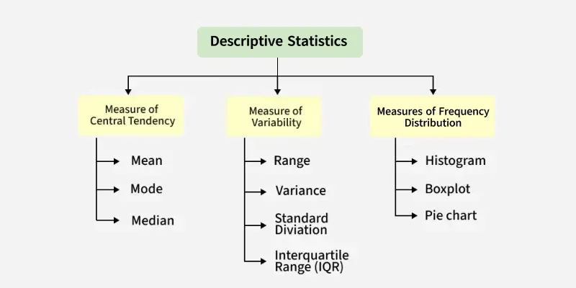

A. Measures of Central Tendency
- Mean (Average)
- It is the sum of all values divided by the number of observations.
- Sensitive to outliers
- Formula:
Population Mean (μ) and Sample Mean (x̄)
μ = (Σxᵢ) / N | x̄ = (Σxᵢ) / n
N = population size, n = sample size, xᵢ = individual observations. Use sample mean (x̄) when working with sample data, which is almost always the case in data science.

- Median
- Middle value in sorted data
- Best for skewed data
- Formula:
- For ungrouped data:
- If n is odd: Median = value at position (n + 1) / 2
- If n is even: Median = average of values at positions n/2 and (n/2 + 1)

- Mode
- Most frequent value
- Used for categorical data

B. Measures of Dispersion
- Range
- Difference between max and min
Range = Maximum − Minimum

- Variance
- The average of the squared deviations from the mean. Squaring ensures negative deviations don't cancel positive ones, and penalizes large deviations more heavily.
Population Variance (σ²) and Sample Variance (s²)
σ² = Σ(xᵢ − μ)² / N | s² = Σ(xᵢ − x̄)² / (n−1)
The sample variance uses (n-1) in the denominator — called Bessel's correction — to produce an unbiased estimate of the population variance. Using n would systematically underestimate the true variance.

- Standard Deviation
- Standard deviation is the square root of the variance, making it easier to interpret because it returns to the original units:
Standard Deviation (SD)
σ = √(σ²) | s = √(s²)
The square root of variance. Expressed in the SAME UNITS as the original data (unlike variance, which is squared units). This makes SD interpretable: 'the average distance of observations from the mean'.

- Indicates spread of data
  - A smaller standard deviation indicates values are close to the mean, while a larger one shows they are more spread out.

- Interquartile Range (IQR):
- Q3 - Q1 (middle 50% of data, robust to outliers).
IQR (Interquartile Range)
IQR = Q3 − Q1
Q1 = 25th percentile (first quartile), Q3 = 75th percentile (third quartile). IQR measures the spread of the middle 50% of the data and is robust to outliers — the primary reason it is preferred in exploratory analysis and box plot construction.

C. Measures of Shape
Shape statistics describe how data is distributed relative to a normal distribution.
- Quartiles (Q1, Q2=median, Q3), Percentiles.
- Skewness (asymmetry of distribution: positive/right-skewed, negative/left-skewed, zero=symmetric).
- Kurtosis (tailedness: high = heavy tails/outliers).

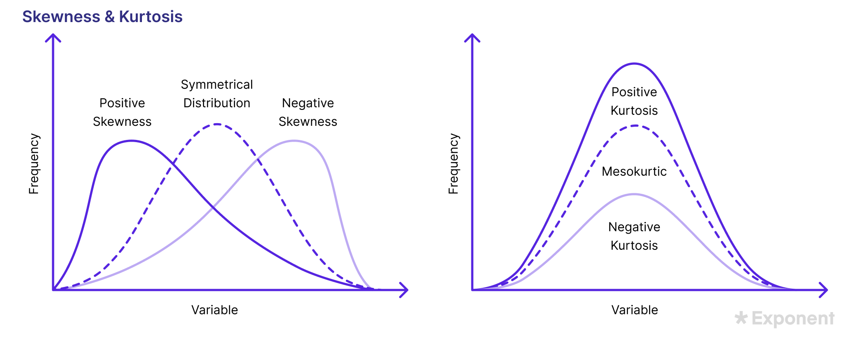
In data science and statistics, skewness and kurtosis help us understand how data is distributed. These two concepts reveal important characteristics about the shape of your data’s distribution.

Understanding Skewness: Definition and Importance
Skewness tells you whether your data is symmetrical or skewed in one direction.
- Measures the asymmetry of the data distribution.
- Positive skew means the data has a long tail on the right side.
- Negative skew means the data has a long tail on the left side.
- Symmetrical data means the distribution forms a shape like a bell curve.
- Important for statistical modeling, hypothesis testing, and data analysis.

Types of Skewness: Positive, Negative, and Symmetrical
There are three main types of skewness you might encounter in a dataset:
- Positive Skew (Right Skew):
  - Most values are concentrated on the left side, with a long tail extending to the right side.
  - Examples: income data, housing prices.
  - Mean is greater than the median.
- Negative Skew (Left Skew):
  - Most values are concentrated on the right, with a long tail extending to the left.
  - Examples: age at retirement, test scores in a difficult exam.
  - Mean is less than the median.
- Symmetrical Distribution:
  - Data is evenly distributed on the left and right sides of the mean.
  - Example: normal distribution.
  - Mean is equal to the median.

Interpreting Skewness in Data Analysis
Interpreting skewness helps you understand whether data follows the expected patterns and guide decision-making:
- Positive skew may indicate that outliers or extreme values are present on the higher end of the distribution.
- Negative skew might suggest that low-value outliers are influencing the dataset.
- Symmetrical data suggests a normal distribution, often assumed in parametric tests like t-tests.

Understanding Kurtosis: Definition and Its Role
Kurtosis measures the tailedness of the data distribution. It shows how much of your data is in the extreme ends (tails) compared to a normal pattern.
- Kurtosis tells us if the data has a lot of outliers or very high and low values.
- High kurtosis means heavy tails, meaning more data points are far from the mean.
- Low kurtosis means light tails, meaning fewer extreme values.
- Mesokurtic distribution has normal kurtosis, and looks like the bell curve.
- High or low kurtosis can indicate the need for data transformation before statistical modeling.

Summary of this topic
- Skewness & kurtosis are essential for understanding the shape & behavior of your data.
- Skewness reveals whether your data is asymmetric.
- Kurtosis shows if there are any outliers or very extreme values in your data.
- Both are important for statistical analysis, hypothesis testing, and data modeling.

Reference: https://datascienceschool.in/descriptive-statistics-in-data-science/

3.2 Data Visualization Techniques
Visualization helps to understand patterns visually.

1. Histogram
- Shows distribution of data
👉 Use: Identify skewness and spread

A histogram is a graphical representation used in statistics to show the distribution of continuous numerical data. The data is grouped into class intervals (bins), and the height of each bar shows the frequency of values.
A histogram helps us understand the shape of the data, such as peaks, spread, and whether the data is symmetric or skewed.
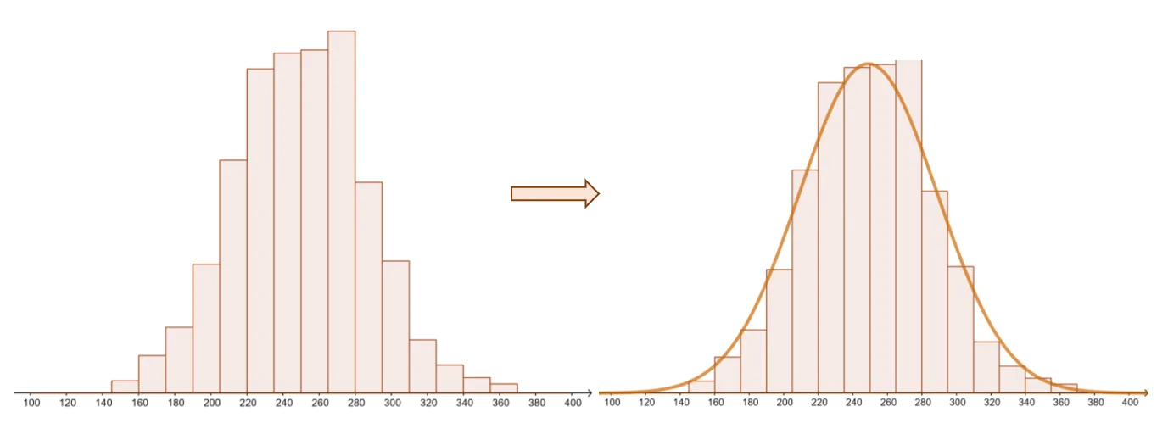

Types of Histogram
There are various variations of the histograms based on their shapes:
Uniform Histogram
A uniform histogram is a histogram in which all the bars are nearly equal in height, showing that the data is evenly distributed among all class intervals.
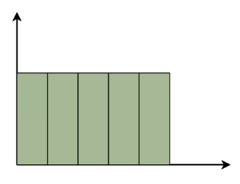
Bimodal Histogram
A histogram is called bimodal if it has two distinct peaks. This shows that the data consists of observations from two different groups or categories, and each group has its own centre or pattern of values.
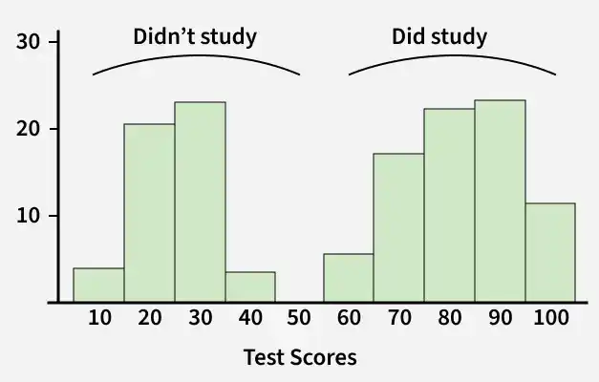
Real-World Examples
- Heights in a Population: One peak for children, another for adults.
- Exam Scores: One peak for students who studied (high scores), another for those who didn't (low scores).
- Traffic Patterns: Peaks during morning and evening rush hours.

Symmetric Histogram
A symmetric histogram is also called a bell-shaped histogram. It is said to be symmetric when a vertical line drawn through the centre divides the histogram into two identical halves. The left and right sides are equal in size and shape, showing a balanced distribution of data.
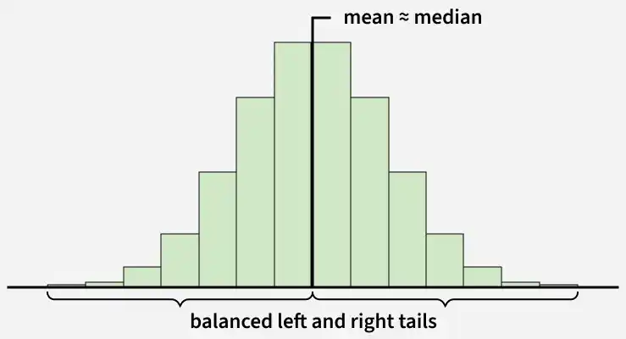

Right-Skewed Histogram
A right-skewed histogram is a histogram in which the bars extend more towards the right side. This means that most of the data values are on the left side, while a few very large values lie on the right.
For example: In a histogram showing family incomes, most families may have lower incomes, but a few very rich families stretch the data towards the right.
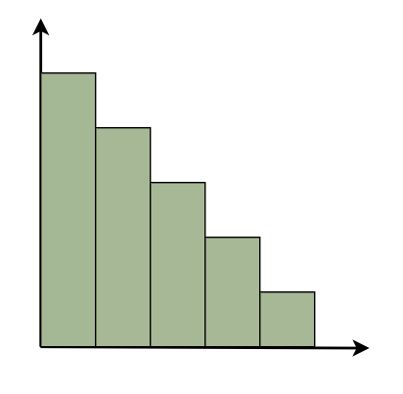
Left-Skewed Histogram
A left-skewed histogram shows bars that extend towards the left side. This means that most of the data values are on the right side, while a few very low values lie on the left.
For example: In a histogram showing test scores, most students may score high marks, but a few students with very low scores stretch the distribution towards the left.
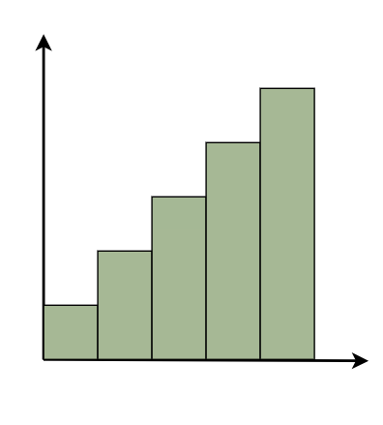
Common Histogram Shapes
Shape Type | What It Indicates
Normal | Symmetric distribution, most values near center
Right-skewed | Many low values, few high values
Left-skewed | Many high values, few low values
Bimodal | Two dominant groups exist
Uniform | Values spread evenly across all bins

Reference: https://www.geeksforgeeks.org/maths/histogram/

2. Box Plot
- Displays:
  - Median
  - Quartiles
  - Outliers
👉 Use: Detect outliers

A Box Plot is also known as a Box and Whisker Plot and it is a graphical tool used to understand the distribution of numerical data. It shows the median, quartiles and possible outliers in a simple visual form.

It helps compare distributions between groups with ease.
- multiple groups effectively.
- Identify outliers quickly and visually.
- Reveal data symmetry or skewness at a glance.
- Show variability clearly even for large datasets.
- Provide compact summaries of data using quartiles and range.
- Useful for comparing multiple groups or categories.

Interquartile Range (IQR)
The box in a box plot represents the Interquartile Range (IQR).
IQR=Q3​−Q1​

It covers the middle 50% of the data, making it a strong measure of spread that is resistant to extreme values.

Identifying Outliers in a Box Plot
Outliers are values that lie outside the upper and lower limits:
Lower Limit = Q1​−1.5×IQR
Upper Limit = Q3​+1.5×IQR

- Any value below the lower limit or above the upper limit is treated as an outlier and shown as a separate point.
- The minimum and maximum whiskers represent the closest values within these limits.

Components of a Box Plot
A Box Plot visually represents the five-number summary of a dataset:
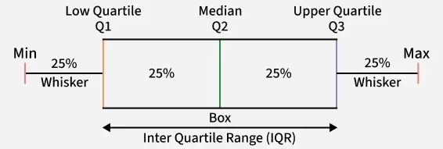

The box plot shown in the above diagram is a perfect plot with no skewness. The plots can have skewness and the median might not be at the center of the box.
- Minimum: The smallest non-outlier value shown at the lower whisker end.
- First Quartile (Q1): The value below which 25% of the data lies.
- Median (Q2): The middle value that splits the data into two equal halves.
- Third Quartile (Q3): The value below which 75% of the data lies.
- Maximum: The largest non-outlier value shown at the upper whisker end.

How to Create a Box Plot
Consider the runs scored by a cricket team in 12 matches: 100, 120, 110, 150, 110, 140, 130, 170, 120, 220, 140, 110
Step 1: Arrange Data in Ascending Order
- 100, 110, 110, 110, 120, 120, 130, 140, 140, 150, 170, 220

Step 2: Find Quartiles and Median
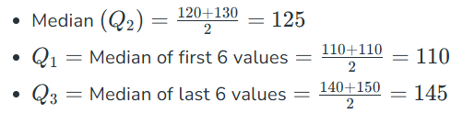
Step 3: Compute IQR
- IQR=145−110=35

Step 4: Calculate Limits
- Lower Limit=110−1.5×35=57.5
- Upper Limit=145+1.5×35=197.5

Step 5: Identify Min, Max and Outliers
- Minimum (within limit) = 100
- Maximum (within limit) = 170
- Outlier = 220

This information is then used to draw the box plot.
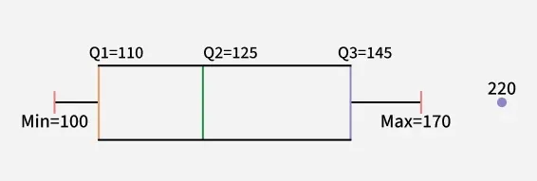Box Plot

Use-Cases of Box Plots
Common use-cases include:
- Exploratory Data Analysis (EDA): Helps quickly detect spread, skewness and extreme values.
- Comparing Multiple Groups: Useful for visualizing differences in distributions across categories.
- Quality Control and Process Monitoring: Detects unusual deviations or anomalies in manufacturing and processes.
- Statistical Reporting: Provides a compact visual summary for large datasets.

How to Compare Box Plots
Comparing multiple box plots helps understand differences between groups in terms of center, spread, skewness and outliers.
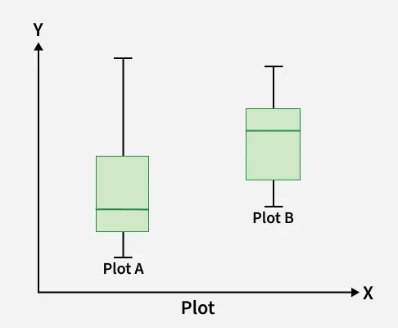
1. Compare the medians (center lines)
- The line inside each box shows the median (middle value).
- Higher median → usually indicates larger overall values.
- Compare which box has its median higher or lower.

2. Compare the Dispersion/Spread (box length)
- The box represents the interquartile range (IQR) (middle 50% of data).
- A wider/taller box → more variability.
- A narrower box → data is more consistent.
- Plot A with a bigger box and whiskers has more variable data.

3. Compare Outliers
- Points outside the whiskers are outliers.
- More outliers → more unusual values in that dataset.
- Fewer outliers suggest more stable and predictable values.

4. Compare Skewness
- If median is in the middle of the box → roughly symmetric.
- If median is closer to one side:
  - Closer to bottom → right-skewed
  - Closer to top → left-skewed
- Plot A is left-skewed and Plot B is right-skewed, showing clear distribution differences.

Difference Between Vertical and Horizontal Box Plot
Here we compare vertical and horizontal box plot
Feature | Vertical Box Plot | Horizontal Box Plot
Orientation | Box is drawn vertically along the y-axis | Box is drawn horizontally along the x-axis
Best For | Comparing numerical values across categories. | Showing distribution when category labels are long.
Readability | Can become cramped with many categories. | More readable when dataset has many labels.
Common Use | Default plot in most statistical tools. | Useful for survey data, ratings and long text labels.
Space Utilization | Requires more vertical space. | Utilizes horizontal space more efficiently.

Advantages
- Easy Comparison: Allows quick comparison of distributions across multiple groups.
- Outlier Detection: Clearly highlights unusual or extreme values in the data.
- Quartile-Based Summary: Summarizes data using median and quartiles instead of raw values.
- Resistant to Noise: Less affected by extreme values compared to mean based visuals.
- Compact Representation: Presents a large amount of statistical information in a clean, compact format.

Limitation
- No Distribution Shape: Does not reveal whether data is normal, uniform or multi-peaked.
- Mean Not Visible: Shows median and quartiles but hides the average value.
- Cannot Detect Multi-Modality: Fails to identify multiple peaks or clusters in the data.
- Less Useful for Small Samples: Provides limited insights when dataset size is very small.

3. Scatter Plot
- Shows relationship between two variables
👉 Use: Identify correlation

A scatter plot, also called a scatter graph or scatter chart, uses dots to describe two different numeric variables. The position of each dot on the horizontal and vertical axes indicates values for an individual data point.
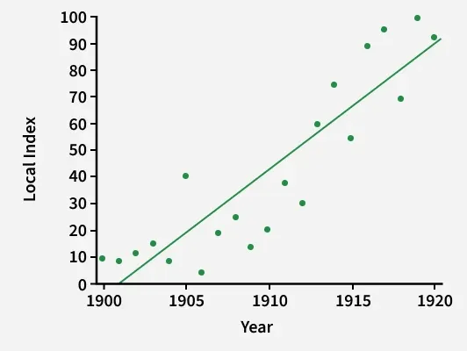

It is generally used to plot the relationship between one independent variable and one dependent variable, where an independent variable is plotted on the x-axis and a dependent variable is plotted on the y-axis so that you can visualize the effect of the independent variable on the dependent variable.

Applications of Scatter Plot
As already mentioned, a scatter plot is a very useful data visualization technique. A few applications of scatter plots are listed below.
- Correlation Analysis: A scatter plot is useful in the investigation of the correlation between two different variables. It can be used to find out whether two variables have a positive correlation, negative correlation, or no correlation.
- Outlier Detection: Outliers are data points that are different from the rest of the data set. A scatter plot is used to bring out these outliers on the surface.
- Cluster Identification: In some cases, scatter plots can help identify clusters or groups within the data.

Construction of Scatter Plot
To construct a scatter plot, we have to follow the given steps.
Step 1: Identify the independent and dependent variables
Step 2: Plot the independent variable on the x-axis.
Step 3: Plot the dependent variable on the y-axis.
Step 4: Extract the meaningful relationship between the given variables.

In the following table, a data set of two variables is given.
Matches Played | 2 | 5 | 7 | 1 | 12 | 15 | 18
Goals Scored | 1 | 4 | 5 | 2 | 7 | 12 | 11

Now in this data set there are two variables: first is the number of matches played by a certain player, and second is the number of goals scored by that player. Suppose we aim to find out the relationship between the number of matches played by a certain player and the number of goals scored by him/her. For now, let us discard our obvious intuitive understanding that the number of goals scored is directly proportional to the number of matches played. For now, let us assume that we just have the given dataset and we have to extract the relationship between the given data pair.
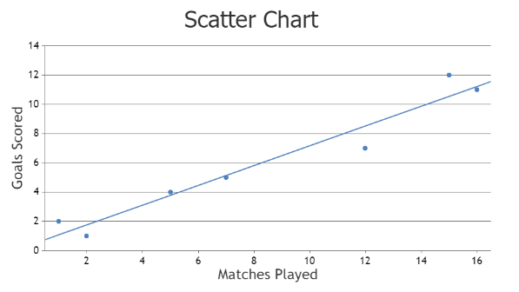s
As you can see in the given scatter plot, there is some kind of relationship between the number of matches played and the number of goals scored by a certain player.

Types of Scatter Plot
On the basis of the correlation of two variables, scatter plots can be classified into the following types.
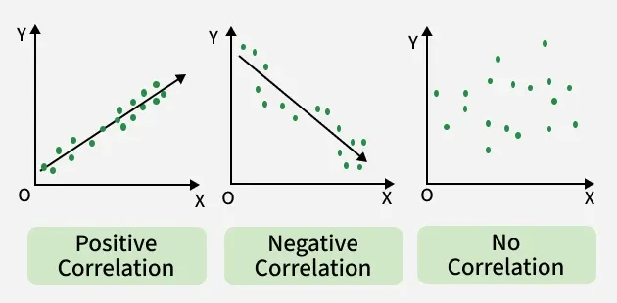

1. Scatter Plot For Positive Correlation
In this type of scatterplot, the value on the y-axis increases on moving from left to right. In more technical terms, if one variable is directly proportional to another, then the scatter plot will show positive correlation. Positive correlation can be further classified into perfect positive, high positive, and low positive.

2. Scatter Plot For Negative Correlation
In this type of scatterplot, the value on the y-axis decreases on moving from left to right. In other words, the value of one variable is decreasing with respect to the other. Positive correlation can be further classified into perfect negative, high negative, and low negative.

3. Scatter Plot For No Correlation
In this type of scatterplot, values are scattered all over the graph. Generally this kind of graph represents that there is no relationship between the two variables plotted on the scatter plot.

Solved Examples on Scatter Plot
Example 1: Draw a scatter plot for the given data that shows the number of IPL matches played and runs scored in each instance.
Matches Played | 10 | 12 | 14 | 16 | 18
Runs Scored | 287 | 300 | 297 | 350 | 345

Solution:
- X-axis: Number of Matches Played
- Y-axis: Number of Runs Scored

Graph:
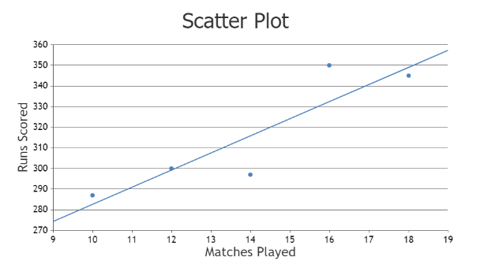

Example 2: Prices (in dollars) and the ratings (out of 5 stars) of 5 different restaurants are recorded and plotted on a scatter plot. Interpret the scatter plot to determine if there is any relationship between price and rating.
Restaurant | A | B | C | D | E
Prices (in dollars) | 22 | 29 | 15 | 18 | 23
Ratings (out of 5 stars) | 3.5 | 4.0 | 3.0 | 4.0 | 3.5

Solution:
- X-axis: Prices (in dollars) of restaurant
- Y-axis: Ratings (out of 5 stars)

Graph:
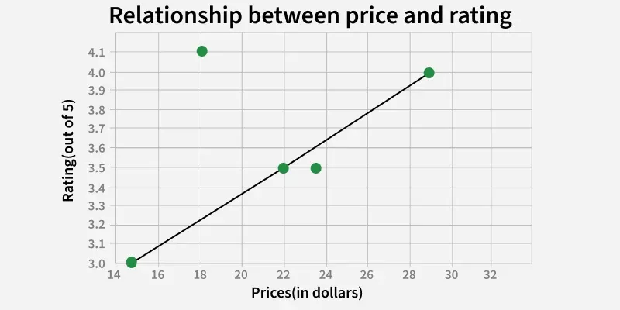

Real-Life Examples of Descriptive Statistics
Descriptive statistics is widely used in various real-life scenarios to help understand, summarize, and interpret data. By applying these techniques, you can gain insights that guide decisions in business, healthcare, education, and more.

Business and Marketing: Understanding Customer Behavior
Descriptive statistics helps businesses understand their customers’ preferences and behaviors.
- Mean and median can be used to calculate the average sales per customer.
- Mode helps identify the most popular product or service.
- Bar charts and histograms visualize customer data (e.g., age groups, purchasing patterns).
- Measures of dispersion like standard deviation help understand the variability in sales.
- Businesses use these statistics to target the right audience and optimize marketing strategies.

Healthcare: Analyzing Patient Data
Healthcare professionals use descriptive statistics to summarize and interpret patient data.
- Mean age, median weight, and mode for common diagnoses provide insights into patient demographics.
- Histograms show the distribution of blood pressure levels or cholesterol in a patient population.
- Box plots are useful to check for outliers in patient health data, like extreme cholesterol levels.
- Standard deviation helps measure the variability in patient conditions and treatment responses.

Education: Understanding Student Performance
In education, descriptive statistics is used to analyze student performance and improve teaching methods.
- Average test scores (mean) help evaluate overall student performance.
- Median scores can give a better sense of typical performance, especially if there are outliers.
- Mode helps identify the most common grade in a class.
- Teachers use bar charts to visualize class attendance or subject preference.
- Standard deviation helps measure spread in student scores, guiding curriculum adjustments.
Sports: Analyzing Athlete Performance
Descriptive statistics is frequently used in sports to assess and improve athlete performance.
- Mean and median are used to calculate average score or time in races or games.
- Histograms visualize the distribution of scores in a competition.
- Box plots help identify athletes with extreme performances (outliers).
- Standard deviation gives insights into consistency of player performance.
- Coaches and analysts use these metrics to evaluate strengths, spot weaknesses, and improve training.

Finance: Analyzing Stock Market Data
In finance, descriptive statistics is crucial for analyzing stock market trends and investment options.
- Mean and median help calculate average stock prices over time.
- Range and variance show price fluctuations of stocks.
- Histograms visualize the distribution of investment returns.
- Standard deviation measures the risk or volatility of an investment.
- Investors and analysts use these statistics to make informed investment decisions.

Social Media: Analyzing User Engagement
Social media platforms use descriptive statistics to track and improve user engagement.
- Mean number of likes, shares, and comments help measure overall engagement on posts.
- Bar charts visualize the popularity of different posts, hashtags, or topics.
- Histograms help understand the distribution of likes across posts.
- Mode can identify the most shared post.
- Standard deviation helps measure the consistency of engagement across multiple posts
Government: Analyzing Census Data
Governments use descriptive statistics to analyze large sets of data collected in census surveys.
- Mean can show the average household income or average family size.
- Mode identifies the most common occupations in a population.
- Bar charts visualize the distribution of ages or education levels.
- Box plots help detect outliers or extreme values in census data.
- This data helps in policy making, resource allocation, and planning for public services.

Summary of this topic
Descriptive statistics is not just for academic purposes—it plays an essential role in real-world applications across industries. Whether it’s business, healthcare, education, or sports, these statistics provide valuable insights that help improve decision-making and problem-solving.
- Use mean, median, and mode for central tendency analysis.
- Apply standard deviation to measure variability.
- Use charts and graphs for easy data visualization.
- Descriptive statistics is important for making data-driven decisions.

3.3 Identifying Patterns and Anomalies

Patterns
EDA is fundamentally about pattern recognition. A pattern is any regularity, structure, or systematic relationship that appears consistently in the data. Identifying patterns guides feature engineering, model selection, and hypothesis generation.
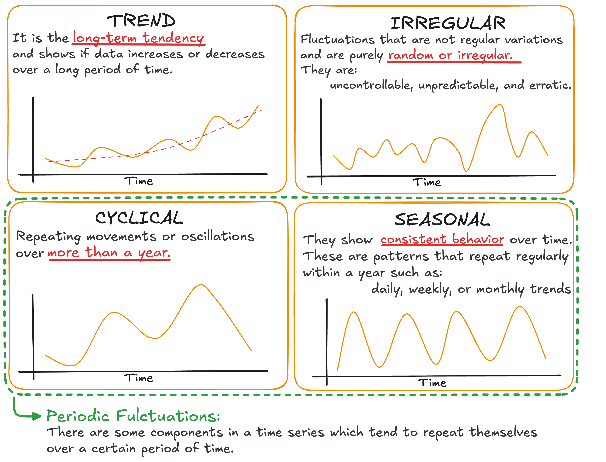

Pattern Type | Description | Detection Method
Trend | Consistent long-term increase or decrease in a variable over time | Line chart, moving average, regression line
Seasonality | Repeating pattern at a fixed period (daily, weekly, annual) | Time-series decomposition, autocorrelation plot
Cyclical Patterns | Irregular fluctuations longer than seasonality (e.g., business cycles) | Long-horizon line charts, economic indicators
Correlation | Two variables consistently move together (positively or negatively) | Scatter plot, correlation matrix, heatmap
Clusters/Segments | Subgroups of observations that are more similar to each other than to the rest | Scatter plot with hue, PCA plots, k-means preview
Distribution Shape | The overall form of a variable's distribution | Histogram, KDE, Q-Q plot
Step Changes | Sudden, persistent shifts in a variable's level | Line chart, control charts, CUSUM analysis

Anomalies (Outliers or unusual observations)
Data points that differ significantly

- Outliers: Extreme values that don't fit the pattern (detect via box plots, z-scores > 3, or IQR method).
- Anomalies can be errors (data entry mistakes), interesting cases (fraud in transactions), or natural extremes.
- Always investigate context before removing — they might carry valuable information.

Causes of Anomalies
- Data entry errors
- Measurement errors
- Rare events

Detection Methods
- Box plot
- Z-score
- IQR method

Why Important?
- Can distort analysis
- May represent important rare events (e.g., fraud detection)

3.4 Correlation and Covariance Analysis

A. Covariance
- Measures direction of relationship
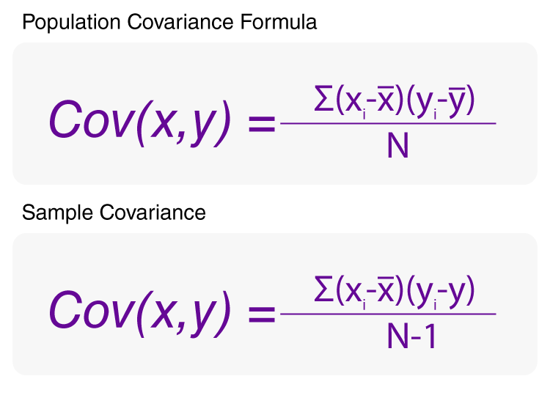
where
- X_{i}: Represents the i^{th} value of variable X.
- Y_{i}: Represents the i^{th} value of variable Y.
- N: Represents the total number of data points.

Interpretation:
- Positive → Variables increase together
- Negative → One increases, other decreases

B. Correlation
- Measures strength + direction
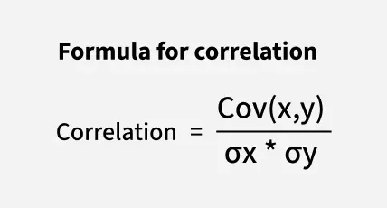
Where,
- Cov(X, Y): Represents the covariance between variables X and Y.
- σ_{X}: Represents the standard deviation of variable X.
- σ_{Y}​: Represents the standard deviation of variable Y.

Correlation Values
Value | Meaning
+1 | Perfect positive
0 | No relationship
-1 | Perfect negative

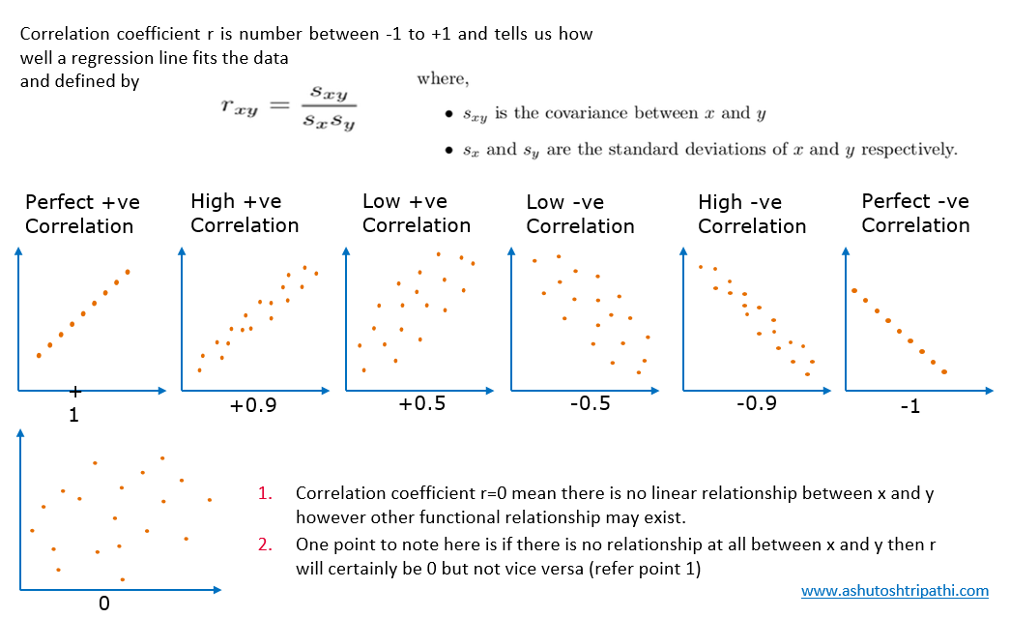

👉 Types:
- Pearson Correlation (linear)
- Spearman Correlation (rank-based)

Important Note
👉 Correlation ≠ Causation

Differences Between Correlation and Covariance
Although correlation and covariance are closely related, they differ in terms of interpretation, scale, and standardization. Understanding these differences is critical for data analysts conducting quantitative studies.
Aspect | Covariance | Correlation
Definition | Measures how two variables change together | Measures strength and direction of a linear relationship.
Formula | Cov(X,Y) = Σ(Xi - X̄)(Yi - Ȳ) / (n-1) | r = Cov(X,Y) / (σX * σY)
Range | Unbounded (–∞ to +∞) | Between –1 and +1
Unit | Has units | Unit free
Interpretation | Indicates direction of relationship | Indicates both direction and strength
Standardization | Not standardized | Standardized measure
Sensitivity to Scale | Affected by changes in scale | Unaffected by changes in scale
Application | Used in intermediate steps of statistical modeling | Used in feature selection and predictive modeling

Applications of Correlation and Covariance in Data Analysis
Both covariance and correlation play vital roles in data analysis and statistical and data modeling, each serving unique purposes. Let’s explore how data analysts use these concepts across industries.

1. Financial Data Analysis
In finance, covariance analysis is used to evaluate how two asset returns move together. For example, investors analyze the covariance between two stocks to assess portfolio diversification.

A positive covariance means the assets move in the same direction, while negative covariance indicates they move oppositely, reducing overall portfolio risk.

In contrast, correlation analysis helps understand the strength of this relationship, guiding investment decisions more precisely.

2. Business Forecasting and Market Trends
Businesses use correlation analysis to measure relationships between variables like sales and advertising, price and demand, or customer satisfaction and revenue by performing sales analytics.

A high positive correlation between advertising spend and sales indicates that increased marketing efforts directly influence revenue growth.

Meanwhile, covariance analysis assists in evaluating the overall movement patterns of variables before calculating correlation.

3. Machine Learning and Predictive Modeling
In machine learning, correlation helps identify features with strong relationships to target variables. Data analysts use correlation matrices to detect multicollinearity or redundant predictors before building models.

Covariance is integral in Principal Component Analysis (PCA) a dimensionality reduction technique that uses covariance matrices to identify directions of maximum data variance.

4. Risk Management and Portfolio Optimization
Financial data analysts rely on covariance analysis to measure how asset returns move together. The covariance matrix forms the basis of Modern Portfolio Theory (MPT), which aims to minimize risk for a given level of return.

Correlation, on the other hand, helps visualize asset relationships more clearly, ensuring that portfolio components are not overly dependent on each other.

Limitations of Covariance and Correlation
Limitations of Covariance:
- Covariance depends on the units used making it hard to interpret if the variables are measured in different units.
- It only works for straight-line relationships and doesn’t capture more complex or curved relationships.
- Covariance doesn’t show how strong the relationship.

Limitations of Correlation:
- Correlation assumes a straight-line relationship and doesn’t work well with non-linear relationships.
- Correlation can be heavily affected by outliers.
- Correlation is best for normally distributed data and may not be reliable for skewed data.

Reference:
https://datamites.com/blog/correlation-vs-covariance-for-analysis/
https://medium.com/@ryassminh/covariance-and-correlation-in-machine-learning-practical-applications-and-insights-1dbe8cee1e1a
https://builtin.com/data-science/covariance-vs-correlation

3.5 Introduction to Hypothesis Testing
A statistical method to make decisions using data.

Hypothesis testing compares two opposite ideas about a group of people or things and uses data from a small part of that group (a sample) to decide which idea is more likely true. We collect and study the sample data to check if the claim is correct.
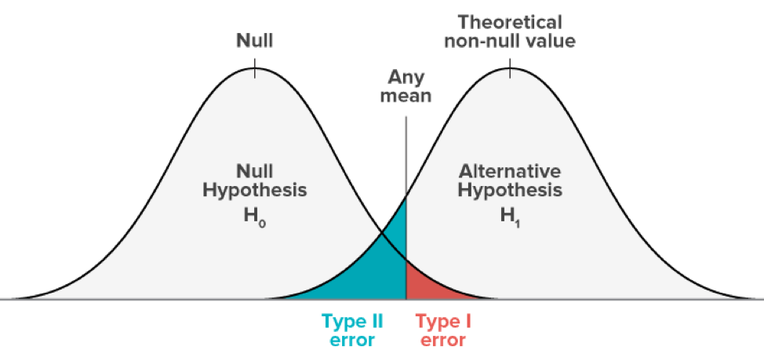
Fig: Hypothesis Testing
For example, if a company says its website gets 50 visitors each day on average, we use hypothesis testing to look at past visitor data and see if this claim is true or if the actual number is different.
Defining Hypotheses
- Null Hypothesis (H₀): The starting assumption. For example, "The average visits are 50."
- Alternative Hypothesis (H₁): The opposite, saying there is a difference. For example, "The average visits are not 50."

Key Terms of Hypothesis Testing
To understand the Hypothesis testing firstly we need to understand the key terms which are given below:
- Significance Level (α): How sure we want to be before saying the claim is false. Usually, we choose 0.05 (5%).
- p-value: The chance of seeing the data if the null hypothesis is true. If this is less than α, we say the claim is probably false.
- Test Statistic: A number that helps us decide if the data supports or rejects the claim.
- Critical Value: The cutoff point to compare with the test statistic.
- Degrees of freedom: A number that depends on the data size and helps find the critical value.

Types of Hypothesis Testing
It involves basically two types of testing:
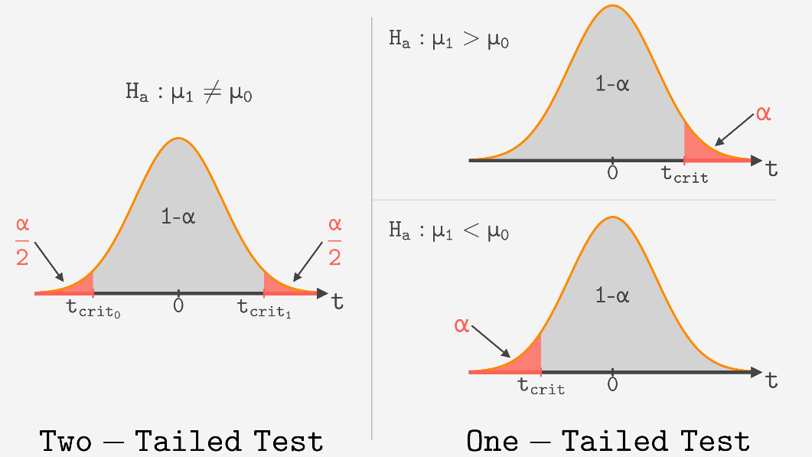

1. One-Tailed Test
Used when we expect a change in only one direction either up or down, but not both. For example, if testing whether a new algorithm improves accuracy, we only check if accuracy increases.

There are two types of one-tailed test:
- Left-Tailed (Left-Sided) Test: Checks if the value is less than expected. Example: H₀​:μ≥50 and H₁: μ<50
- Right-Tailed (Right-Sided) Test: Checks if the value is greater than expected. Example: H₀ : μ≤50 and H₁:μ>50

2. Two-Tailed Test
Used when we want to see if there is a difference in either direction higher or lower. For example, testing if a marketing strategy affects sales, whether it goes up or down

Example: H₀: μ= 50 and H₁: μ≠50
To go deeper into differences into both types of test: Refer to link

What are Type 1 and Type 2 errors in Hypothesis Testing?
In hypothesis testing Type I and Type II errors are two possible errors that can happen when we are finding conclusions about a population based on a sample of data. These errors are associated with the decisions we made regarding the null hypothesis and the alternative hypothesis.
- Type I error: When we reject the null hypothesis although that hypothesis was true. Type I error is denoted by alpha(α).
- Type II errors: When we fail to reject the null hypothesis even though it is false, Type II errors are denoted by beta(β).

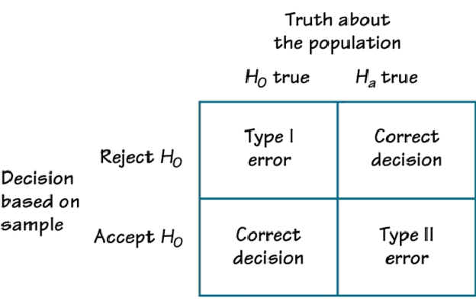

Steps in Hypothesis Testing
- Formulate Hypotheses: Define H₀ and H₁
- Set Significance Level (α): Determine the threshold (e.g., usually 0.05).
- Select Test Statistic: Choose the appropriate test (e.g., T-test, z-test, Chi-square).
- Calculate p-value: Analyze the data to determine the p-value.
- Make decision or Conclusion: Compare p-value to α to reject or fail to reject H₀

Step 1: Define Hypotheses:
- Null hypothesis (H₀): Assumes no effect or difference.
- Alternative hypothesis (H₁): Assumes there is an effect or difference.

Example: Test if a new algorithm improves user engagement.
Note: In this we assume that our data is normally distributed.

Step 2: Choose significance level
We select a significance level (usually 0.05). This is the maximum chance we accept of wrongly rejecting the null hypothesis (Type I error). It also sets the confidence needed to accept results.

Step 3: Collect and Analyze data.
- Now we gather data this could come from user observations or an experiment. Once collected we analyze the data using appropriate statistical methods to calculate the test statistic.
- Example: We collect data on user engagement before and after implementing the algorithm. We can also find the mean engagement scores for each group.

Step 4: Calculate Test Statistic
The test statistic measures how much the sample data deviates from what we did expect if the null hypothesis were true. Different tests use different statistics:
- Z-test: Used when population variance is known and sample size is large.
- T-test: Used when sample size is small or population variance unknown.
- Chi-square test: Used for categorical data to compare observed vs. expected counts.
- ANOVA: Used to compare the means of three or more independent groups.
- A/B Testing: A practical application to compare two versions of a webpage, product, or model to see which performs better.

Step 5: Make a Decision
We compare the test statistic to a critical value from a statistical table or use the p-value:
1. Using Critical Value:
- If test statistic > critical value → reject H₀​.
- If test statistic ≤ critical value → fail to reject H₀​.

2. Using P-value:
- If p-value ≤ α → reject H₀​.
- If p-value > α → insufficient evidence to reject H₀​, not proof that H₀​ is true.

Example: If p-value is 0.03 and α is 0.05, we reject the null hypothesis because 0.03 < 0.05.

Step 6: Interpret the Results
Based on the decision, we conclude whether there is enough evidence to support the alternative hypothesis or if we fail to reject the null hypothesis.

Real life Examples of Hypothesis Testing
A pharmaceutical company tests a new drug to see if it lowers blood pressure in patients.
Data:
- Before Treatment: 120, 122, 118, 130, 125, 128, 115, 121, 123, 119
- After Treatment: 115, 120, 112, 128, 122, 125, 110, 117, 119, 114

Step 1: Define the Hypothesis
- Null Hypothesis: (H₀)The new drug has no effect on blood pressure.
- Alternate Hypothesis: (H₁)The new drug has an effect on blood pressure.

Step 2: Define the Significance level
Usually 0.05, meaning less than 5% chance results are by random chance.

Step 3: Compute the test statistic
Using paired T-test analyze the data to obtain a test statistic and a p-value. The test statistic is calculated based on the differences between blood pressure measurements before and after treatment.
t = m/(s/√n)

Where:
- m = mean of the difference i.e X after, X before
- s = standard deviation of the difference (d)
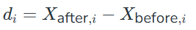
- n = sample size

then m= -3.9, s= 1.37 and n= 10. we calculate the T-statistic = -9 based on the formula for paired t test

Step 4: Find the p-value
With degrees of freedom = 9, p-value ≈ 0.0000085 (very small).

Step 5: Result
Since the p-value (8.538051223166285e-06) is less than the significance level (0.05) the researchers reject the null hypothesis. There is statistically significant evidence that the average blood pressure before and after treatment with the new drug is different.

Applications
- A/B Testing: Determining if a new website feature increases conversions.
- Machine Learning: Testing if adding a feature significantly improves model performance.
- Business Intelligence: Checking if marketing strategies lead to higher revenue in specific regions.

Reference:
https://www.geeksforgeeks.org/data-science/understanding-hypothesis-testing/
https://www.analyticsvidhya.com/blog/2021/07/hypothesis-testing-made-easy-for-the-data-science-beginners/

3.6 Effective Data Interpretation
Interpretation is the final step of EDA.
Interpretation is the art of EDA — turning statistics and plots into actionable insights.

Effective data interpretation in data science transforms raw analytical outputs into actionable insights by contextualizing findings, identifying patterns, and driving strategic decisions. It bridges the gap between what the data shows (analysis) and why it matters (interpretation).
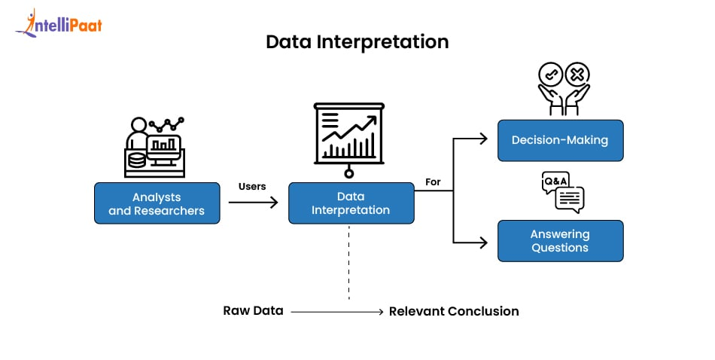

Key Principles
- Understand Context
- Domain knowledge is essential

- Avoid Bias
- Do not manipulate results

- Focus on Insights
- Not just numbers, but meaning

- Use Visualization
- Communicate clearly

- Simplify Results
- Make understandable for non-technical users

Example
Instead of saying:
❌ "Mean = 70"
Say:
✅ "Students performed above average, indicating good academic performance"

Best Practices:
- Context matters: Always relate findings to the business/domain problem. Ask "So what?"
- Avoid over-interpretation: Don't jump to causation from correlation. Consider confounding variables.
- Be skeptical: Question assumptions. Look for data quality issues (missing values, biases, inconsistencies).
- Use multiple views: Combine statistics + visualizations + domain knowledge. One plot alone can mislead.
- Document everything: Note patterns, anomalies, decisions (e.g., why you treat an outlier a certain way). This creates reproducibility.
- Storytelling: Summarize key takeaways clearly (e.g., "The data is right-skewed with several high-value outliers likely representing premium customers").
- Iterative process: EDA is not one-time — clean data, re-explore, refine questions.

Common Pitfalls:
- Ignoring missing data patterns.
- Over-relying on averages when distributions are skewed.
- Cherry-picking visuals.
- Forgetting that sample ≠ population.

Reference:
https://www.commercengine.io/blog/data-interpretation
https://www.geeksforgeeks.org/aptitude/data-interpretation-1/

Summary (Quick Revision)
- EDA helps understand data before modeling
- Descriptive statistics summarize data
- Visualization reveals patterns and outliers
- Correlation shows relationships
- Hypothesis testing helps in decision-making
- Interpretation converts data into insights

Mini Python Example (EDA)
import pandas as pd
import matplotlib.pyplot as plt

# Sample dataset
data = pd.read_csv("data.csv")

# Descriptive statistics
print(data.describe())

# Histogram
data['age'].hist()
plt.show()

# Scatter plot
plt.scatter(data['age'], data['salary'])
plt.xlabel("Age")
plt.ylabel("Salary")
plt.show()

# Correlation
print(data.corr())

Possible Exam Questions
Short Questions (2–3 Marks)
- Define mean, median, and mode
- What is a histogram?
- Define correlation
- What is hypothesis testing?

Long Questions (5 Marks)
- Explain descriptive statistics with examples
- Describe data visualization techniques
- Explain correlation and covariance
- Discuss hypothesis testing steps
- Explain effective data interpretation

Histogram Questions
- Construct a histogram for the following data:
12, 15, 18, 20, 22, 25, 27, 30, 32, 35, 38, 40
- Group the following data into class intervals and draw a histogram:
5, 8, 12, 15, 18, 20, 22, 25, 27, 30, 35, 40, 45
- Find the frequency distribution table and create a histogram for students' marks:
22, 25, 28, 30, 32, 35, 36, 38, 40, 42, 45, 48, 50
- Draw a histogram for the age distribution:
10, 12, 13, 15, 17, 18, 20, 22, 24, 25, 27, 29
- Create class intervals of width 10 for the following dataset and draw a histogram:
11, 15, 18, 22, 24, 28, 31, 35, 37, 40, 44, 48, 50
- Find the modal class from the histogram created using the data:
5, 7, 9, 10, 12, 14, 15, 18, 20, 21, 22, 24
- The frequencies of marks are given below. Draw a histogram:
Class Interval | Frequency
0–10 | 3
10–20 | 5
20–30 | 9
30–40 | 7
40–50 | 4
- Draw a histogram and estimate the mode from the following grouped data:
Class Interval | Frequency
10–20 | 4
20–30 | 8
30–40 | 15
40–50 | 10
50–60 | 5
- Compare two histograms and identify which dataset has greater spread.
- Create a histogram for daily temperatures recorded over 15 days:
20, 22, 23, 24, 25, 26, 27, 28, 28, 29, 30, 31, 32, 33, 35
- Determine the class width for the following intervals:
0–5, 5–10, 10–15, 15–20
- Explain why histograms are useful for continuous data.
- Draw a histogram for the following grouped data and identify the highest frequency class:
Class Interval | Frequency
0–10 | 2
10–20 | 6
20–30 | 12
30–40 | 8
40–50 | 3
- Calculate the frequency density for the grouped data:
Class Interval | Frequency
0–5 | 10
5–15 | 20
15–20 | 5
- Use the frequency density formula:

- A histogram has class intervals of unequal width. Explain how you would adjust the histogram.
- Draw a histogram from the following frequency table:
Weight (kg) | Frequency
40–50 | 4
50–60 | 7
60–70 | 12
70–80 | 9
80–90 | 3
- Identify whether the histogram is symmetric, positively skewed, or negatively skewed based on given data.
- Estimate the median class from a histogram.
- Differentiate between a histogram and a bar graph with examples.

Questions on Box Plot:
- Find the five-number summary (Minimum, Q1, Median, Q3, Maximum) for the dataset:
5, 7, 8, 12, 13, 15, 18, 21, 24
- Construct a box plot for the dataset:
10, 12, 14, 15, 18, 21, 23, 24, 27, 30
- Calculate the interquartile range (IQR) for the data:
4, 8, 10, 12, 14, 16, 18, 20, 22
- Identify the outliers in the dataset using the IQR method:
2, 4, 5, 6, 7, 8, 9, 10, 25
- For a dataset, Q1 = 15 and Q3 = 35. Find the IQR.
IQR=Q3−Q1
- If Q1 = 20 and Q3 = 50, calculate the lower and upper bounds for outliers.
- The five-number summary of a dataset is:
Minimum = 5, Q1 = 10, Median = 15, Q3 = 20, Maximum = 30
Draw and interpret the box plot.
- Given the dataset:
3, 5, 7, 8, 12, 13, 15, 18, 21, 50
Determine whether 50 is an outlier.
- Compare the spreads of these two datasets using box plots:
  - A: 2, 4, 6, 8, 10, 12, 14
  - B: 5, 15, 25, 35, 45, 55, 65
- A box plot has:
- Q1 = 25
- Median = 40
- Q3 = 55
Find the IQR and explain the spread.
- Create a box plot for the marks of students:
45, 50, 55, 60, 62, 65, 68, 70, 72, 90
- Determine whether the following dataset is positively or negatively skewed using the box plot concept:
5, 6, 7, 8, 10, 12, 15, 20, 35
- The minimum and maximum values of a dataset are 12 and 80. If Q1 = 25 and Q3 = 55, identify possible outliers.

Correlation and Covariance
1. Define Correlation and Covariance
Explain correlation and covariance with suitable examples. Differentiate between them.

2. Numerical Problem on Covariance
Calculate the covariance between X and Y using the following data:
X | Y
2 | 4
4 | 8
6 | 12
8 | 16
Interpret the result.

Questions on Hypothesis Testing
1. One-Sample z-Test (Most Repeated Exam Question)
A company claims that the average weight of a biscuit packet is 500 g. A sample of 36 packets has an average weight of 490 g with population standard deviation 24 g.
Test at 5% significance level whether the company’s claim is true.

2. One-Sample t-Test
A teacher claims that the average marks of students in statistics is 70. A sample of 10 students gives:
68, 72, 75, 70, 69, 74, 71, 73, 67, 70
Test the claim at 5% significance level.

3. Two-Sample t-Test
Two teaching methods are used for two groups of students.
Group A Marks: 65, 70, 68, 72, 66
Group B Marks: 75, 78, 74, 80, 77
Test whether the two teaching methods have significantly different mean performances at 5% significance level.

4. Hypothesis Test for Population Proportion
A factory claims that 90% of its products are defect-free. In a sample of 200 products, 170 are found defect-free.
Test the claim at 5% significance level.

5. Chi-Square Goodness-of-Fit Test
A die is rolled 60 times and the outcomes are:
Face | Frequency
1 | 8
2 | 9
3 | 10
4 | 11
5 | 12
6 | 10
Test whether the die is fair at 5% significance level.

